AI / Non-AI Collaboration Log – Task-Based Template
Complete one log for each major milestone of your project (min. 4 logs total).
Maximum 2 logs per week. Each log should take ~10–15 minutes.
Choose and fill either Path A (AI) or Path B (Non-AI) for each milestone and omit the other, depending on what you used.

Milestone Categories (choose one for each log)
- Planning & Research – defining goals, gathering requirements, outlining scope.
- Design & Architecture – creating structure, workflows, and initial prototypes.
- Core Development – building main features, core functionality, and foundational systems.
- Integration – connecting components, services, or data sources.
- Quality Assurance – testing, debugging, and refining functionality.
- Optimization – improving performance, usability, and efficiency.
- Finalization & Delivery – polishing, documentation, deployment, and handoff.

Log Entry # 1
Milestone Category: planning and research
Date / Week: 18 novemeber
Commit ID / Screenshot link: https://www.figma.com/design/MxWDixHpWKrxq6I80Mlyjp/ID_10273775c_Edith_Assg1_wireframe?node-id=0-1&t=vOTNeoJP7s8Guti0-1

Path A – If you used AI
- Task Description
(1–2 sentences about what you worked on)
Example: “Integrated the weather API and displayed results in a card layout.”
- Ideas for food items
- What are basic things to fill up in certain forms

- AI Input
(Paste 1 AI prompt + 1 snippet of AI output, Share your AI conversations with the share button, share the entire history of the AI chat not the response only.)
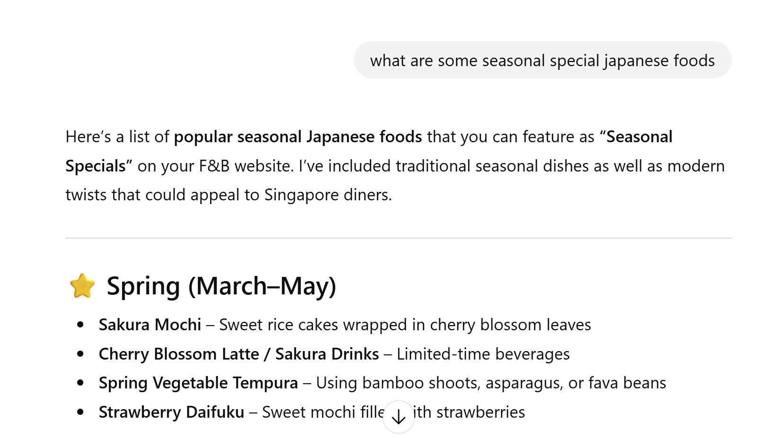
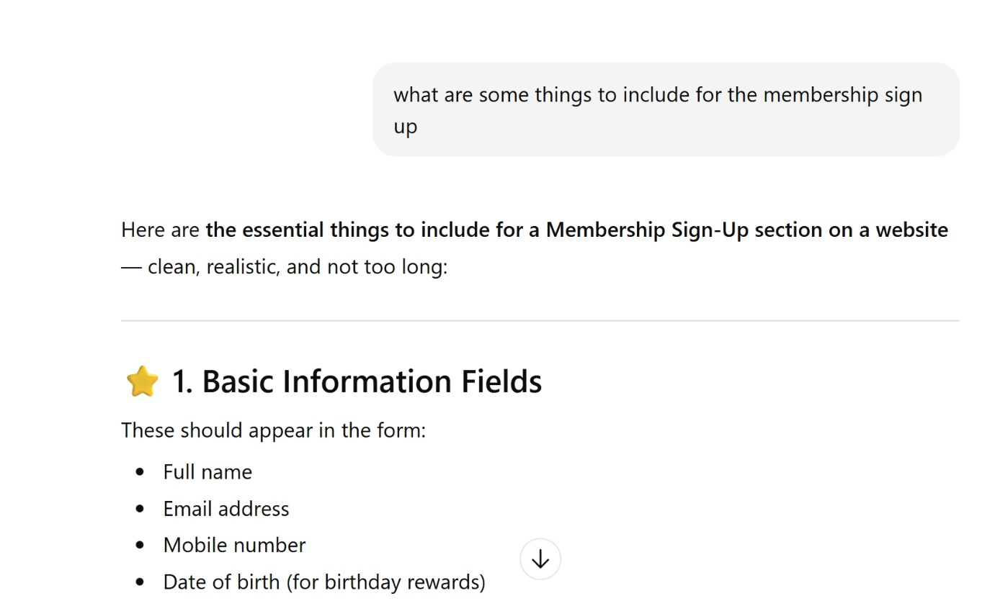

- My Edit / Change
(1–2 sentences: What you modified, why, or what you learned)
Example: “AI didn’t handle API errors. I added try/catch to manage missing data.”
Added some things which I thought were necessary for the company’s logic.

- Reflection Prompt (choose one / add your own)
  - What mistake did AI make, and how did you spot it?
  - What did AI do better/faster than you?
  - What unique decision did you add that AI couldn’t?
  - How would you explain this feature to a non-coder in 2 sentences?
- Ai was useful… no mistakes…
- Ai came up with ideas faster than me
- I came up with certain things that I feel like the company would need but ai didn’t come up with it— Salutation.
- Fast and easy.

Path B – If you did not use AI
- Task Description
(1–2 sentences about what you worked on)
Example: “Created responsive navbar with media queries.”

- Support Source Used
(Document what helped you: docs, tutorials, peers, debugging)
Example: “I used MDN docs on flexbox and StackOverflow for media query syntax.”

- My Edit / Change
(1–2 sentences: What you modified, why, or what you learned)
Example: “The tutorial used px units, I switched to rem units for accessibility.”

- Reflection Prompt (choose one / add your own)
  - What mistake or confusion did you find in the resource, and how did you resolve it?
  - What did the resource help you do more quickly?
  - What unique decision or creativity did you add that wasn’t in the resource?
  - How would you explain this feature to a non-coder in 2 sentences?

